**Resistivity by Four Probe method**

Name : Hardik Shah

Roll No. : 16010221025

Batch : D2

Branch : ETRX

## **Aim:**

## To find the resistivity of a semiconductor by four probe method

**Apparatus:**

The experimental set up consists of probe arrangement, sample , oven 0-200°C, constant current generator , oven power supply and digital panel meter(measuring voltage and current).Four probe apparatus is one of the standard and most widely used apparatus for the measurement of resistivity of semiconductors.

**Diagram:**

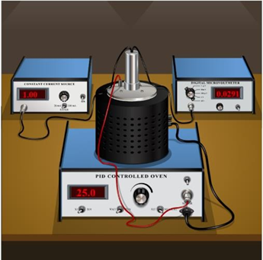

## **Observations Table:**

|  |  |  |  |  |
| --- | --- | --- | --- | --- |
| Obs. No. | Temperature T (K) | Voltage V(V) | Current I (A) | Resistivity ρ (ohm m) |
| 1 | 298 | 2.1810 | 75 | 0.0000620 |
| 2 | 303 | 2.1163 | 75 | 0.0000601 |
| 3 | 308 | 2.0555 | 75 | 0.0000584 |
| 4 | 313 | 1.9984 | 75 | 0.0000568 |
| 5 | 323 | 1.9445 | 75 | 0.0000553 |
| 6 | 328 | 1.8937 | 75 | 0.0000538 |
| 7 | 333 | 1.8458 | 75 | 0.0000524 |
| 8 | 338 | 1.8004 | 75 | 0.0000512 |
| 9 | 343 | 1.7574 | 75 | 0.0000499 |

Plot graph of Temperature (along x-axis) and resistivity (along y-axis)

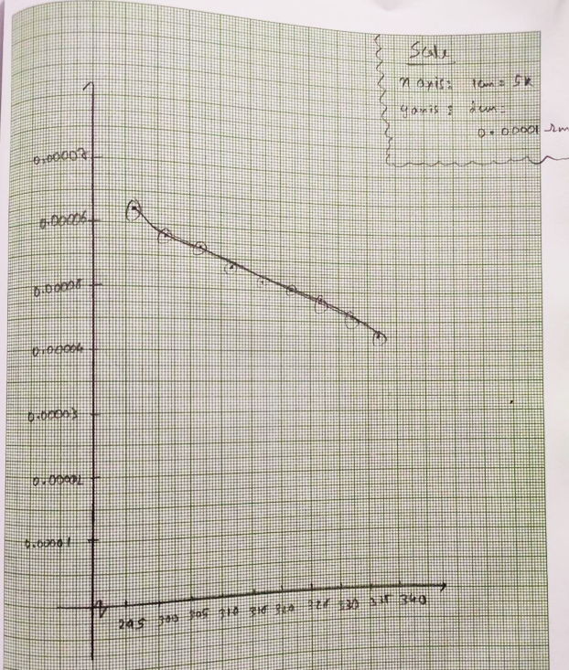

**Calculations:**

Resistivity can be calculated by using the equation given below.

= ………………ohm m

= ……………..ohm m

Given: 1. Distance between the probes (S) = 0.2cm

2. Thickness of the sample, (W) = 0.05cm

3. From standard table f (w/S) = 5.89

### Result: The resistivity of the given semiconductor by four probe method= 0.0000620 Ohm m